Head fixation clamp

The Head clamp to be implanted on the animal’s head is an original design from Alexandra Tran-Van-Minh. The final modifications and FEM stress studies to choose the material for manufacturing have been done by Xavier Cano Ferrer.

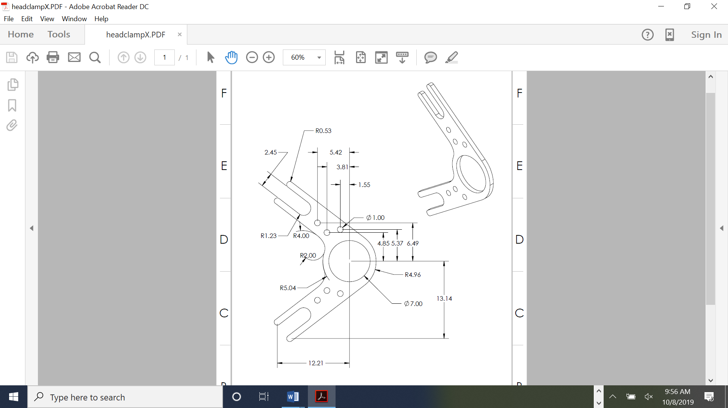
Figure 1: Head clamp drawings.

The following study aims to assess if with the change from the current head clamp (1 mm thickness) to Titanium or Steel, reducing the thickness to 0.8 mm, the head plate performance also improves on stiffness. This would provide better stability for two-photon microscopy in awake animals. This comparison can be performed knowing that the materials will be manufactured using CNC technique from a block of homogeneous and isotropic material.

The three materials simulated on the Solidworks simulation tool have been:

- Aluminum 6061-T6 1 mm of thickness (0.3g).
- Titanium Grade 2 0.8 mm of thickness (0.41g).
- Stainless steel 316 0.8 mm of thickness (0.73g).

The Initial conditions for the simulation are:

- A static load applied to the center ring (Blue arrows on Figure 2).
- Three axis fixture on the parts where the metric 2.5 screws are placed (green arrows on Figure 2).

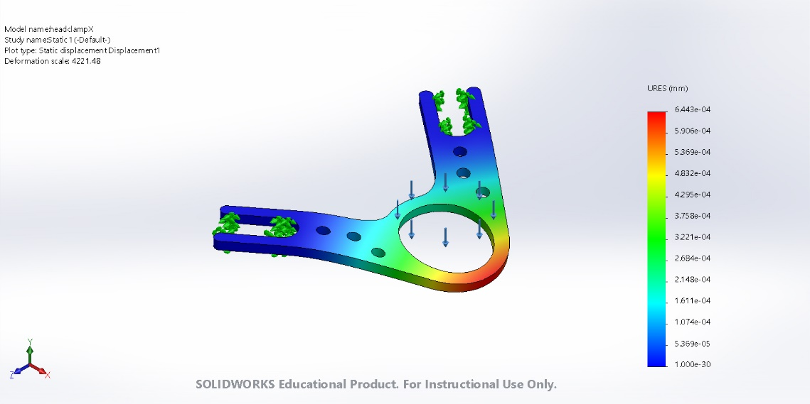
Figure 2: Graphical display of the simulation.

The results of maximum displacements obtained for each condition

- Aluminum max. displacement = 9.445e-04 mm
- Titanium max. displacement = 11.79e-04 mm
- Stainless Steel max. displacement = 6.443e-04 mm

In conclusion, with the stainless steel head plate of 0.8 mm thickness, the displacement and strain of the head clamp is less than the Aluminum one (1 mm). Otherwise with the Titanium we lose stiffness with 0.8 mm thickness.

Finally, the manufacturing supplier was 3D hubs and the chosen material:

CNC machining / Stainless steel 316L / Smoothed (Ra 1.6μm, 63μin)

